Devin Fromond
CS 3220 | A
Lab 01
1/28/2026

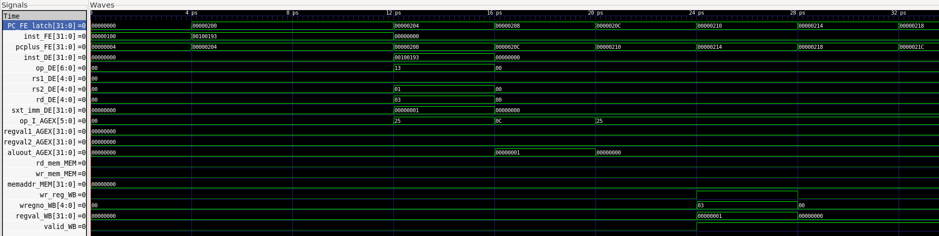
Part 1: Minimal Functionality
In executing test/part1/test1.mem, FE fetches sequential PCs, beginning with 0x0200; DE decodes the ADDI instruction and pulls x0 and the immediate value; AGEX forwards regval1=0, stx_imm=imm into the ALU for addition; MEM (quite trivially) passes through since there is no load/store instruction; WB asserts wr_reg_WB=1 and writes the ALU result into the destination register. The screenshot above highlights how the signals move through the pipeline, emphasizing how there is no MEM signals flipped and op_DE contains the opcode for ADDI (0x13).

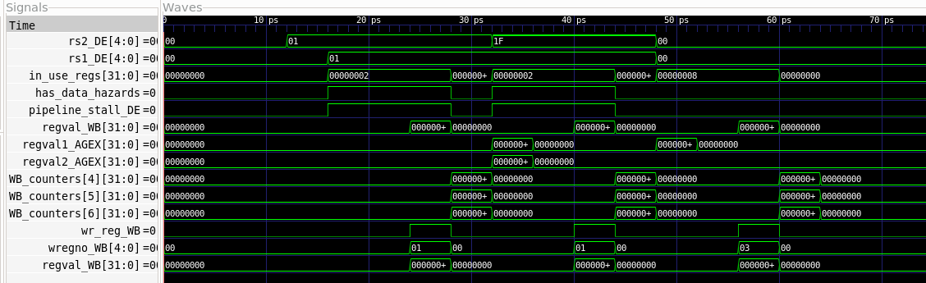
The execution of test/part1/test2.mem shows back-to-back instructions where x6 consumes x5’s result and so on. In the cycle where add x6 reaches AGEX, regval1_AGEX pipes its data from the MEM/WB forward path. Since forwarding succeeds, pipeline_stall_DE and has_data_hazards are low as possible with the provided pipeline. We are able to see a direct connection between in_use_regs and the pipeline_stall_DE and has_data_hazards flags, indicating that, during this time, there is a RAW hazard being processed. However, after those flip to low, we immediately observe WB_counters flip to high, indicating the register write is committing. This waveform highlights how the pipeline handles RAWs since it stalls younger instructions until the producer writes back, then continues once the dependency is cleared.

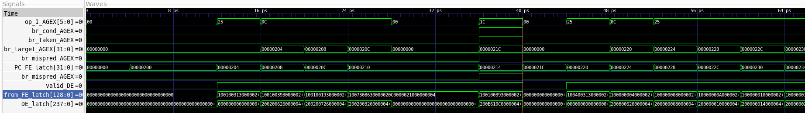
From the waveform above, we observe that for test/part1/test4.mem at the arbitrary cycle N, BEQ evaluates operands, br_taken_AGEX=1 contradicts the not-taken prediction (at the point where the red line is), so br_mispred_AGEX=1 pulses, br_target_AGEX holds the correct PC, FE uses it in cycle N=1, and the younger instruction in DE is flushed – which explains the period of low signals after 40ps.

